GAME : THE GAME

**Genre – Action / Adventure**

Gameplay

**The big picture**

In this VR game, the player is able to draw objects that can then be interacted with in the game environment.

Challenges in the game include fast drawing, choosing the right items to draw for different scenarios and figuring out the weaknesses of boss enemies.

for example - when enemies are coming towards you, you're going to need to draw a shield and a sword quickly before they get you to defeat them, and there could be also enemies that use long range weapons like arrows, so you'll need to draw for yourself some cover to avoid getting hit.

The game takes place in a series of interconnected maps, each with a certain number of areas.

in each area enemies will attack the player then after defeating them the player must find his way through doors, hallways, or gates to progress into the next area, and may need to draw specific objects to pass these pathways, sometimes after defeating the enemies player must solve puzzles in order to move on into the next area of the map towards the main goal which is retrieving the items that got lost in these alternate timelines.

for example - to open a door player must draw its missing lever to open it, if there's a rift between our area and the next area the player will have to draw a platform like a ladder to walk on to be able to cross the gap.

From the beginning of the game, the player will be provided with a list of all the drawings that they can make.

**Background to the Story –**

The story takes place in the far future in a time where everyone could get the most advanced technology easily unsupervised thanks to the corporations who just want to make profit and sell to whoever they can no matter how dangerous the products they sell.

**Story -**

after being asked to do some grocery shopping for your mother as soon as you get to the door of your house u realize you forgot to bring milk, now you being too scared to enter the house with a missing item and too lazy to go all the way back you decide to use a device to go back in time to the grocery store to get that milk, but something goes wrong – the device being sold by a greedy company who doesn’t bother checking it’s quality turns out to be faulty then you find yourself teleporting to different timelines trying to find a way back home.

Your mission now becomes twofold: find a way back home and retrieve the items that scattered among those different timelines to avoid your mother's wrath.

At the beginning of your journey you come across a mysterious tool which gives you the ability to draw a set of things and brings whatever you draw from that set to life, and this tool will help you get through the whole journey.

So the question is - will you be able to make it back home and save the day, or will you be stuck in the alternate timelines forever?

**Scenes -**

1 scene for the story when we get teleported from our home to alternate timelines, and the other 2 scenes are for the maps we play in, each map has 1 scene.

**First scene (could be a bonus scene if there’s not enough time):**

in this scene we get to see the story of this game as we start exactly in front of the entrance of our home and realize that we messed up and from there see how things went wrong. The scene ends when we try to use the faulty device to go back in time and then teleport to and alternate timeline by loading the next scene. In this scene the player won’t do much as he only interacts with the environment by seeing what’s happening around him and then press a button to activate the device and then load the next scene.

**Second, third scene –**

The scenes where we play and get in the action as detailed in the walkthrough, the tutorial is going to be only in the second scene, in the third the player will already know how the game works.

When you activate the drawing ability, a transparent rectangle will appear in front of you, This rectangle acts as a canvas where you can draw the object you want to create. The rectangle will appear on the screen on the side of the controller you used to activate the ability.

Here’s a sketch of the player’s view in the game while using the ability against an enemy –

Here we can see right before the player confirms that he finished drawing, you’ll be able to see the enemy’s health bar just like you can see yours in the bottom left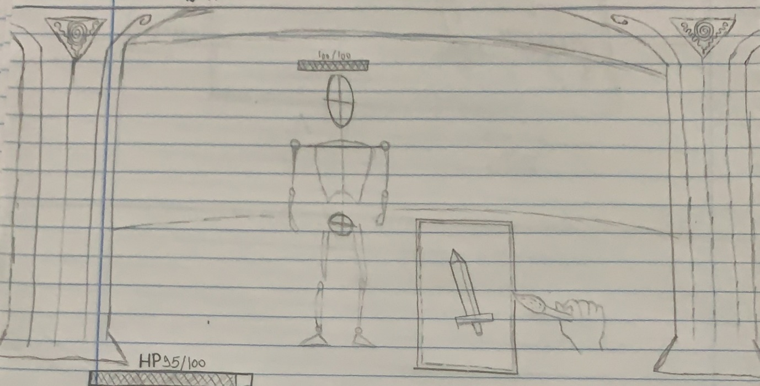

Here’s after confirming the drawing and the player gets to use the sword he drew –

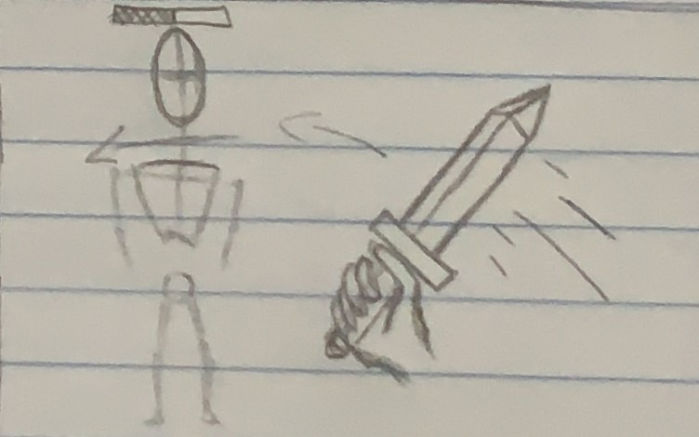

**Mechanics**

- player can jump, dodge, block.

- last second block will allow player to stun the enemy/make the enemy drop the weapon.

- items you draw have a health bar meaning that it will break after a certain amount of use.

- the more accurate the player draws a certain item the more effective it becomes for example – after drawing a weapon like a sword if it’s really accurate to the blueprint of the sword that was given in the beginning of the game you’ll get a sword that will do a lot of damage and will have more durability.

Of course, if you didn’t like what you created maybe because it was not drawn very accurately to the blueprints you could always drop that item and try again to draw better.

- draw levers/handles/ropes to get through pathways to go into the next area on the map.

- draw shovel to dig through to find valuable items or draw hammer to break through walls for example – in some cases there’s going to be a breakable wall separating between your current area to the next one, so you’ll need to draw a hammer to break it.

- player can draw cover for himself for defence, and it’s not only shields to be held by his hand it could also be walls that he can draw so he can take cover from ranged attacks or it could be a strategy to outsmart the enemy for example – draw walls to your right, left and behind in order to leave no choice for the enemy but to come only from one direction and make it easier for you to take them out.

- draw spells: player can also draw things other than objects to interact with in the game, there are spells for defence for example – a spell which makes you invincible for a limited time, a spell to regenerate a small amount of health. There are spells for attacking, for example - boost your weapons for a limited time, shoot a fireball from your hands.

After using a spell you’ll be able to use it again only after a certain amount of time has passed as it will be put in a cooldown.

**walkthrough**

In the beginning of the game after traveling to an alternate timeline the player will spawn only with his fists and will go through a tutorial to learn how to use the drawing ability before going out in the wild.

After getting everything you need to navigate through the map you’ll be constantly facing challenges while going through these areas as you’ll be attacked in most areas you’re going to enter, so you must always be ready to draw as quickly as possible and at the same time make sure that it’s accurate drawing to increase their effectiveness and durability.

You could always prepare yourself before entering an area by equipping whatever you need to survive but you should always keep in mind that these tools you created have a health bar as they will break after a certain amount of use so you’ll have to create new ones at some point and it could always happen mid-fight, in other cases you might enter the area and find out that the things you drew won’t help you in that scenario for example – you enter an area prepared with a sword and a shield but it turns out most enemies use ranged weapons positioned in places you can’t reach so in this scenario the weapons you equipped won’t be useful.

During the game you’ll encounter some puzzles that you have to solve them in order to move into the next area but there are other cases where you’ll have to solve puzzles in order to defeat an enemy, for example – some enemies that you encounter are invincible and the puzzle is to find out where their source of power is coming from and destroy it could be a some sort of a magical pillar hidden in some place and you’ll have to find it and destroy it and this way the invincible enemy will become vulnerable and you will be able to defeat it.

In the final area of the map, you’ll be in a boss fight and must defeat it in order to retrieve the grocery item.

For boss fights you could have one similar to the example mentioned previously, you could also face a boss which summons enemies and you’ll have to defeat him in order to stop the summoning.

**Example to wrap up the walkthrough**

After entering an area 4 enemies will spawn - 2 carrying a sword, 1 wielding a spear and 1 unarmed then the player will choose his strategy to defeat them, as he’s fighting them with his weapons of choice 3 archer enemies will spawn in a location that is out of reach so the player has 2 options here – either draw a bridge so he can come to those archers and eliminate them with the same weapons he drew from the beginning or draw quickly a bow and some cover for himself to defeat them, after clearing the area from enemies the player must find a way to activate a manual elevator that will take him into the next area. To use the elevator, the player must stand on one side and draw a heavy object to place on the other side, causing the elevator to lift and take the player to the next area. Of course, the player must figure out how the elevator operates by himself by looking at the items he can draw and inspecting the environment around him to find some clues to solve that puzzle.

Here's a sketch to the area design to look at the map from above:

Elevator denoted as ?, the player as *, the 4 enemies as stickman figures

And the grey area that surrounds them are rifts so if the player tries to walk there he will fall to his death.

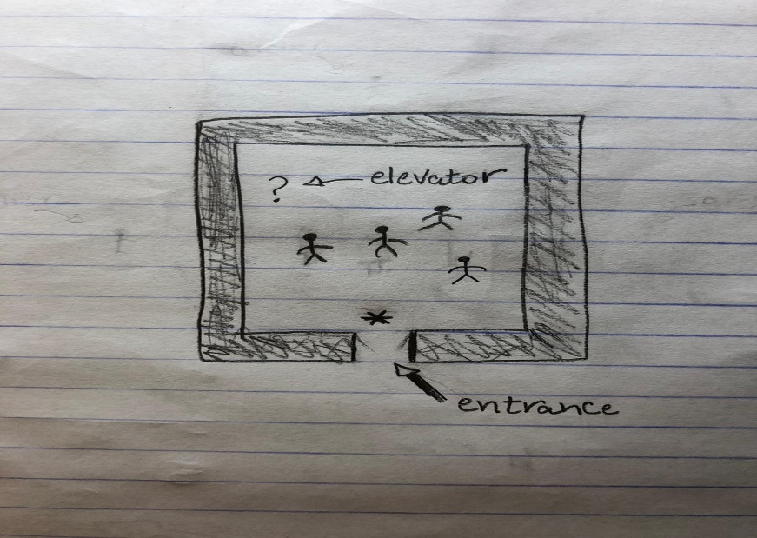

Here’s a sketch when the archers spawn after some time has passed :

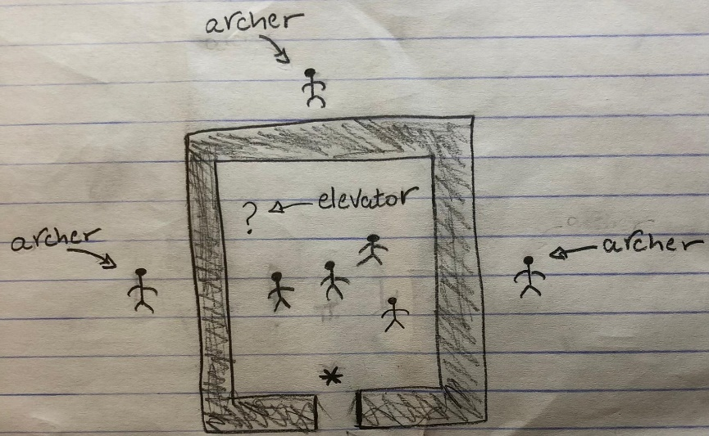

**Controls**

In order to activate the drawing ability, the player must hold a button in the controller and start immediately drawing as soon as he release the button he basically confirms that he finished his drawing, then the game will decide what he drew by comparing his drawing to the blueprints that was given to him in the beginning of the game and give the player the item with the highest percentage of similarity to his drawing.

**Player**

- The Player has a finite health bar. In order to regenerate a portion of it, the player must collect health potions or use a healing spell.

- after dying the player respawns in the last area he completed and the area he died in will reset.

- after completing a map, the player can choose either to continue into the next map or quit the game, if he continued to the next map then he’ll spawn in it with his fists only along with a list of things he can draw that are relevant to the map.

**Enemies**

We’ve seen previously some examples on what happens when entering an area, the enemies in it won’t spawn together at the same time but they will come in waves some will spawn already before you enter the area, some will spawn after you defeated a couple of enemies, some will spawn after a specific amount of time has passed since you entered the area, some will be summoned by other enemies.

The type of enemies you’ll encounter can vary, for example - there are big enemies that have a large amount of health and deal massive damage to the player but move slower than the others, Regular enemies which we are going to see the most are enemies that have a normal amount of health and deal a moderate amount of damage.

While developing the game the type of enemies that will be added will depend on the map itself.